FTF FY 2023 Performance Scorecard USAID Dem Rep Congo

This Feed the Future (FTF) Performance Scorecard assesses the USAID Dem Rep Congo progress toward FY 2030 Performance Targets.

# Performance Overview



The FY 2023 **On track** value is determined by drawing a line from the baseline (FY 2022) to the FY 2030 Target. For FY 2023, Performance Targets are considered **On track** if they have reported at least 90% of that value.

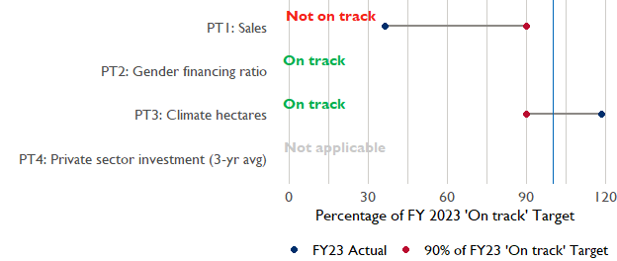

**Note:** *For Performance Target 2 (Gender financing ratio), the target is to increase financing to females for those OUs that are already achieving parity ($1).*

*For Performance Target 4 (PSI), all targets are relative to the last three years’ reporting. In future years, the interim targets may increase.*

*For Performance Target 5 (MDD-W), all FY23 actual values are also the baseline, and may have been collected in a prior year. See the detail page for more information.*

*See detailed* [*methodology document*](https://docs.google.com/document/d/13n-43ppFiGKauscQ7HaAiQDCM4DssGEgRdq2fMyTDn0/edit) *here. If you have questions, please email the FTF Data and Analytics team at* [refs.adl.da@usaid.gov](mailto:refs.adl.da@usaid.gov).

### Performance Target (PT) Details

This section shows PT scores for each applicable PT for USAID Dem Rep Congo.

## Performance Target 1: Value of annual sales of producers and firms receiving USG assistance



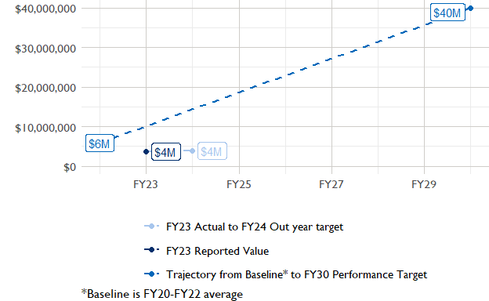

In FY 2023, USAID Dem Rep Congo had 4 activities that aligned the ‘Value of annual sales from producers and firms receiving USG assistance’ (EG.3.2-26), and 4 contributed to the sales total of $3,680,000.

###### Performance Target 2: Value of financing accessed by female FTF participants per $1 of financing accessed by male FTF participants



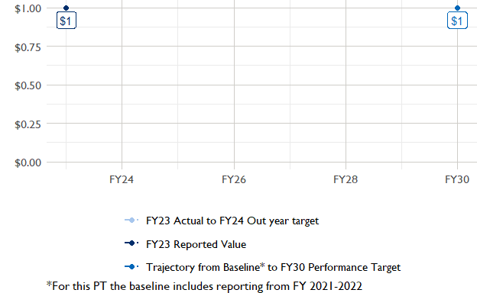

In FY 2023, USAID Dem Rep Congo had 1 IMs/Activities that reported all four sex disaggregates needed to contribute to PT2. The total value of financing among all activities, regardless of disaggregates, was $20,000 (EG.3.2-27 total), with $20,000 that was disaggregated by females and males, and an additional $29,040,000 to ‘mixed’ firms that have both males and females, and NA that was not sex disaggregated.

###### Performance Target 3: Number of cultivated hectares under climate adaptation/climate risk management practices and technologies with USG assistance



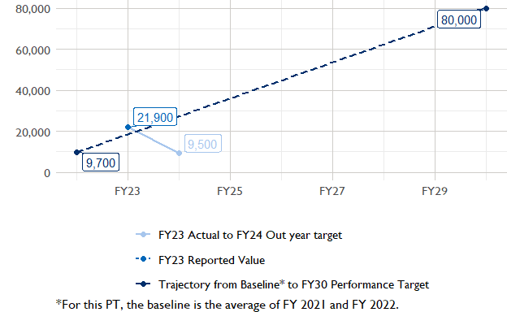

In FY 2023, Dem Rep Congo had 14 activities that aligned the indicator for hectares under improved management practices (EG.3.2-25). Of those activities, 4 reported on the ‘Climate adaptation/climate risk management’ disaggregate and contributed to the OU total for this PT.

###### Performance Target 4: Value of private sector investment leveraged by the USG to support food security and nutrition



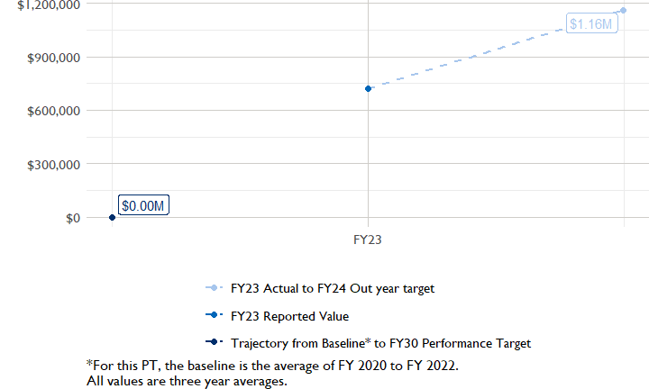

In FY 2023, Dem Rep Congo had 6 activities that aligned the private sector investment indicator (EG.3.1-15/-14), ‘Value of new private sector investment leveraged by the USG to support food security and nutrition [IM-level]’, and 3 contributed to the OU total in FY 2023.

###### Performance Target 5: Percent of women consuming a diet of minimum diversity (MDD-W)



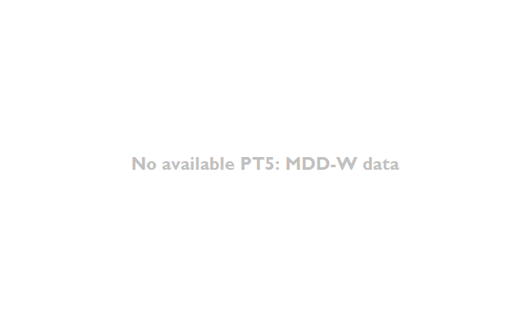

PT5 is not available for USAID Dem Rep Congo.

### National Context

National context data is not available for Dem Rep Congo.

## NULL

## Agricultural Transformation Index Score

The [IFPRI Agricultural Transformation Index (ATI)](https://agrilinks.org/events/drivers-agrifood-system-transformation-lessons-feed-future-country-studies) Score is a high level indicator of the status of agricultural market systems in each country.

## [1] "No Ag Transformation Index available for Dem Rep Congo."

## Budget Trend

At the Operating Unit level, the Performance Targets are based in part on the FY 2024 budget request. The budget chart below includes EG.3 money only.

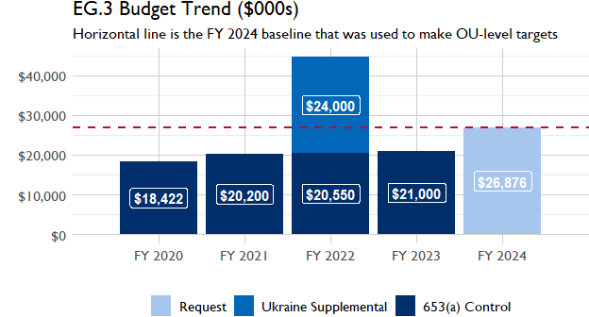

## Active Portfolio

The following activities are considered “active” based on their reporting in FY 2023 and expected FY 2024 reporting. The Analytics, Data and Learning Division defines an “active” activity as one that reported targets, actuals, or deviation narratives for the current year (FY 2023), or the next out year targets (i.e. FY 2024).

## Top Activities (Award Disbursements and Results)

This section highlights some activities in the USAID Dem Rep Congo (DROC) portfolio that have the highest level of disbursements and high reporting values for the relevant indicators. The table below shows the top (up to) five activities by the total transaction amount for disbursements. The columns to the right indicate if these activities are reporting on relevant PT indicators.

| Award Number | Activity Code | Activity Name | FY23 Disbursements | PT1 | PT2 | PT3 | PT4 |
| --- | --- | --- | --- | --- | --- | --- | --- |

**The next table (below) shows the top reporting activities.**

| Award Number | Activity Code | Activity Name | Total Disbursements | Sales | Hectares | PSI |
| --- | --- | --- | --- | --- | --- | --- |
| 72066021CA00005 | 4596 | Gorilla Coffee Alliance | NA | $1,717,583 | NA | NA |
| AID-FFP-A-16-00009 | 1917 | Enyanya - Development Food Security Activity Sud-Kivu and Tanganyika | NA | $1,230,667 | 1 178 | NA |
| AID-FFP-A-17-00001 | 1914 | Budikadidi Development Food Security Activity | NA | $472,685 | 11 111 | NA |
| 7200AA18D00020 | 3177 | Feed the Future (FTF) Democratic Republic of Congo (DRC) Strengthening Livelihoods and Resilience (SLR) | NA | $255,795 | NA | $133,921 |
| 72066019LA00002 | 1909 | Management of Fall Armyworm in Maize for Smallholder Farmers in DRC | NA | NA | 9 578 | $16,370 |

### Appendix 1: Response to “Not on track” Performance Targets

This section provides space for USAID Dem Rep Congo to provide an explanation of why the following PTs are not on track and how you could adjust to be on track in the coming year(s). To help in your response(s), the relevant section of the FTF/GFS Key Issue Narrative (KIN) is provided, as it *may be* useful in drafting a responses. Note that the KIN is addressing the sum of the out year targets (FY 2023) set by the USAID Dem Rep Congo activities that are reporting on each PT. The FY 2023 out year targets were set prior to the establishment of the FY 2030 Performance Targets, so the below explanations from the KIN may not apply to the Performance Target deviation.

* In Section 4 of the FTF KIN, your OU discusses FY24 and FY25 targets, while these Scorecards are addressing progress against a trajectory from historical reporting to your OU’s FY30 target.  Also, the FY 2023 out year targets were set prior to the establishment of the FY 2030 Performance Targets.  Therefore, the below explanations from the KIN may not apply to these FY30 Performance Target deviations.
* These responses will be used to compile a Congressional report, the GFSS Implementation Report, to discuss progress against the FTF FY 2030 Performance Targets, as mandated by the GAO.
* Only PTs that are ‘Not on Track’ require review and explanation from the OU.

## Performance Target 1: Sales

*Excerpt from FY23 KIN Section 4 to consider:*strengthened capacity of private and public sector actors, coupled with a more favorable business policy environment, will encourage agribusinesses to engage in productive and resilient markets that will lead to increased sales, increased employment, and enterprise growth. FTF in DRC prioritizes policy, governance, and regulatory reforms to improve agri-food system efficiencies which increase sales and incomes of smallholder farmers, MSMEs, indigenous peoples, women and youth. FTF works to deepen economic connectivity between agricultural market corridors within the DRC, expanding and sustaining linkages between producers, aggregators, processors, buyers, and end market consumers, leading to more reliable inputs, increased transactions and more resilient markets. Continuing to improve these connections will add tremendous value to the agriculture and food market system, expanding access to markets and increasing sales and household incomes for producers. As a new FTF Focus Country, new programming in development will seek to build off of successes and lessons learned to continue to drive transformational change in the agri-food system, through direct partnership and targeted interventions at the producer, firm, and enterprise level. The Mission anticipates that leveraging this and other strategies will enable FY 24 targets to be exceeded. By and large, the FY 2023 target for Performance Goal Indicator (PGI) 1 was met. A few main factors contributed to this including expanded implementation in Ituri, the culmination of significant RFSA investments, and strong coffee and cocoa production seasons. Targets for FY 2024 and 2025 are currently lower than the FY 2023 due to a shift in portfolio approach, location and implementation. During this shift, new activities will need to grow from the inception stage to full implementation with results likely to be impacted as a result.

#### Enter USAID Dem Rep Congo (DROC) Response Below: